School Name
Mathematics Test 2017
Year 9 |  | Surds | Non Calculator
Skills and Knowledge Assessed:  - Define rational and irrational numbers and perform operations with surds and fractional indices (ACMNA264) |  |  | Name_________________
Section 1 Short Answer Section
Write all working and answers in the spaces provided on this test paper.

Circle the irrational numbers in the list below.

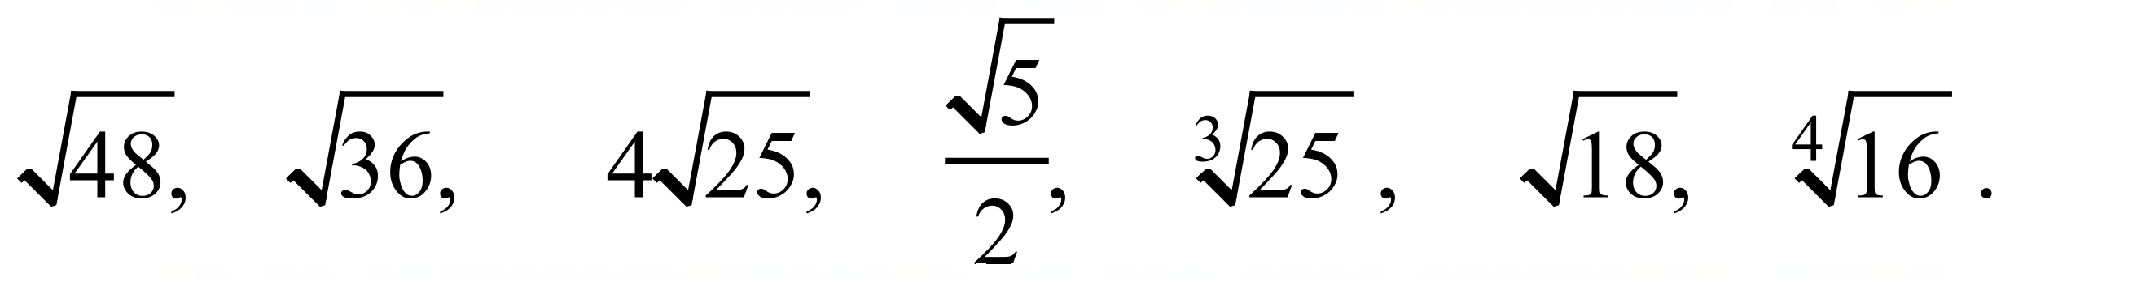

Simplify : 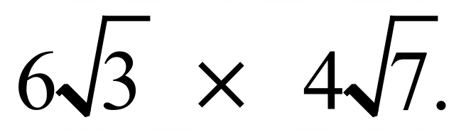

…………………………………………………………………………………………………………
Simplify : 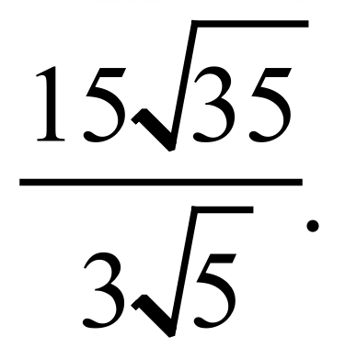
………………………………………………………………………………………………………
Simplify : 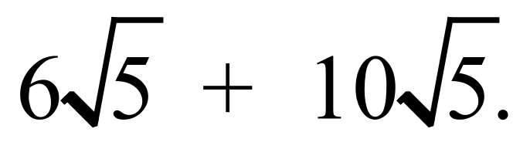

…………………………………………………………………………………………………………
Simplify : 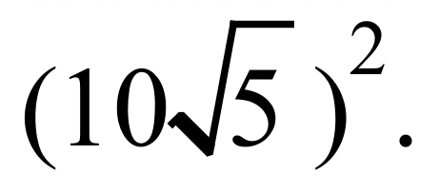

…………………………………………………………………………………………………………
Simplify : 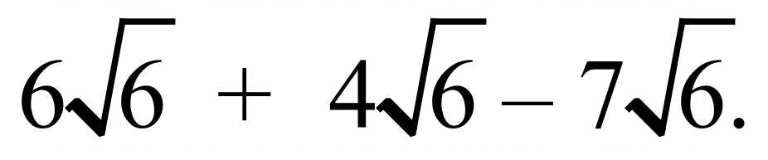

…………………………………………………………………………………………………………
Simplify : 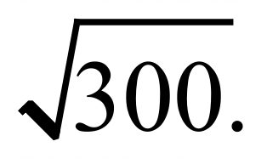

…………………………………………………………………………………………………………
Simplify : 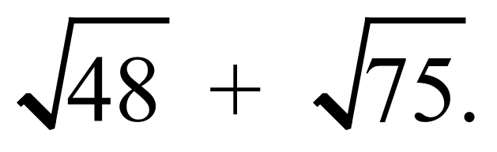

…………………………………………………………………………………………………………
Simplify : 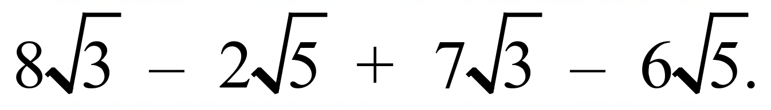

…………………………………………………………………………………………………………
Simplify : 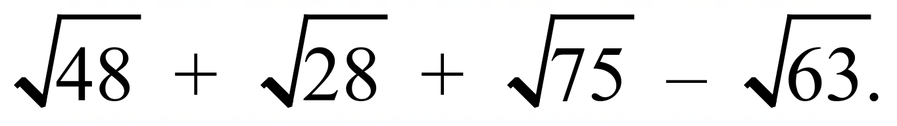

…………………………………………………………………………………………………………

…………………………………………………………………………………………………………
Express with a rational denominator : 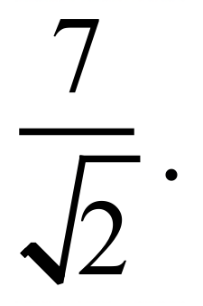

…………………………………………………………………………………………………………
Express with a rational denominator : 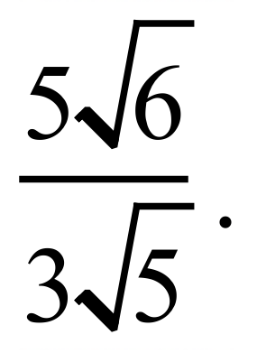

…………………………………………………………………………………………………………
Expand and simplify : 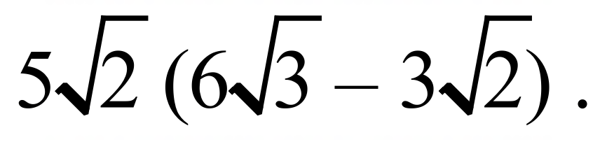

…………………………………………………………………………………………………………
Expand and simplify : 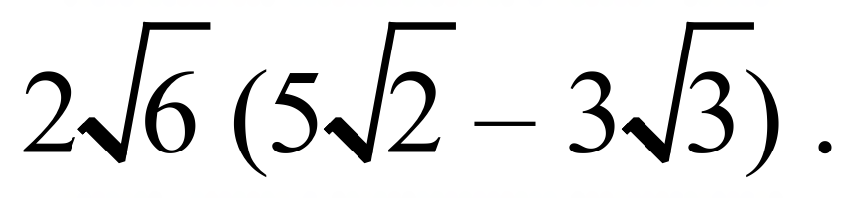

…………………………………………………………………………………………………………

…………………………………………………………………………………………………………
Expand and simplify : 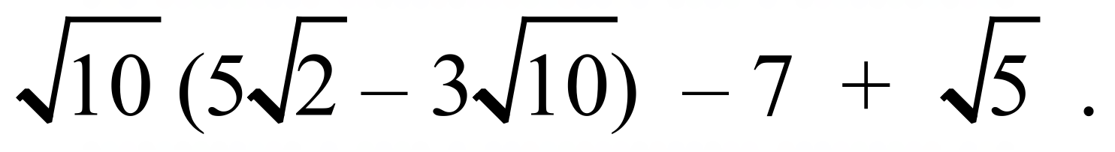

…………………………………………………………………………………………………………

…………………………………………………………………………………………………………
Express in simplest form, with a rational denominator : 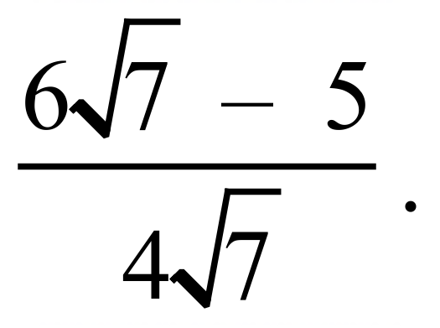

…………………………………………………………………………………………………………

…………………………………………………………………………………………………………
Expand and simplify : 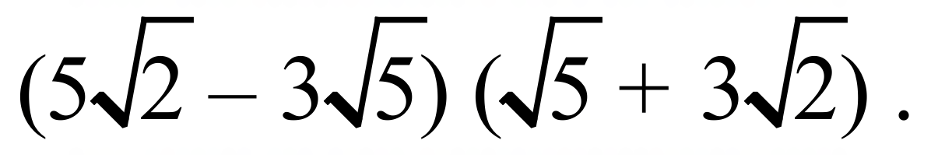

………………………………………………………………………………………………………

…………………………………………………………………………………………………………
Find the values of x and y if 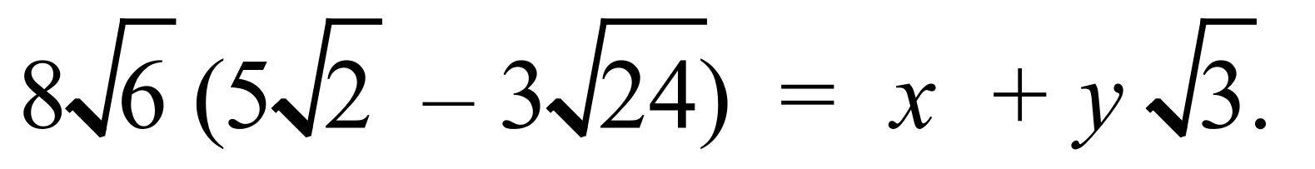

…………………………………………………………………………………………………………

…………………………………………………………………………………………………………
Arrange the numbers 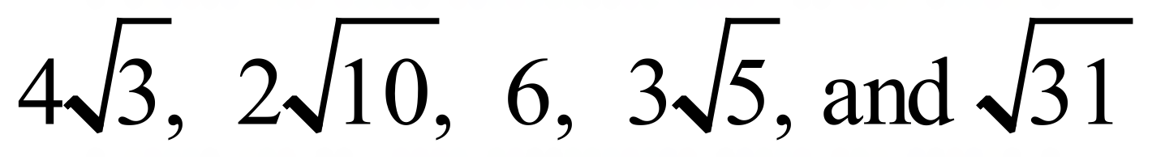in ascending order.

…………………………………………………………………………………………………………

…………………………………………………………………………………………………………

School Name
Mathematics Test 2017
Year 9 |  | Surds | Calculator Allowed
 |  | Surds | Name_________________
Section 2 Multiple Choice Section
Mark all your answers on the accompanying multiple choice answer sheet, not on this test paper. You may do any working out on this test paper. Calculators are allowed for this section.

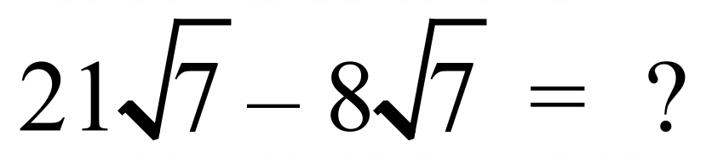

A. 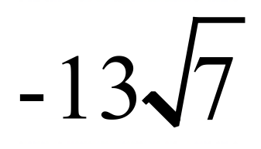 B. 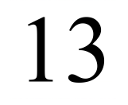 C. 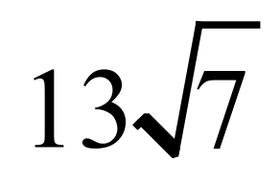 D. 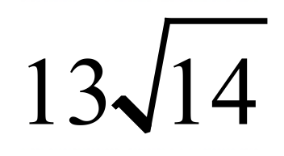
Which of the numbers below is an irrational number?

A. 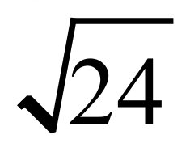 B. 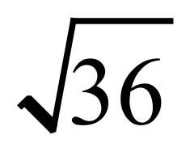 C. 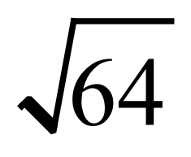 D. 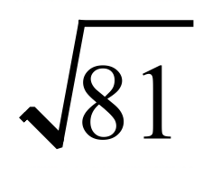
Simplify 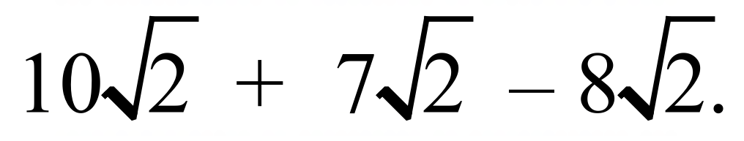

A. 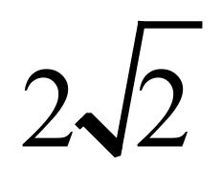 B. 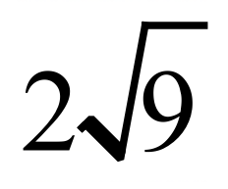 C. 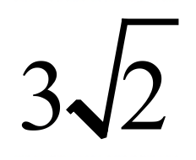 D. 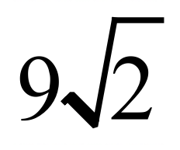
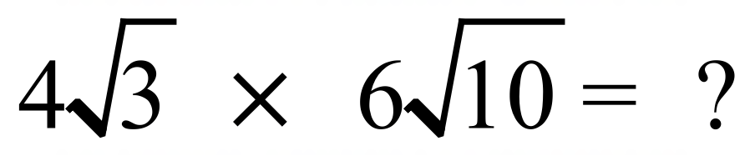

A. 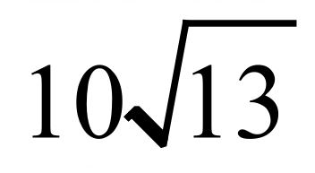 B. 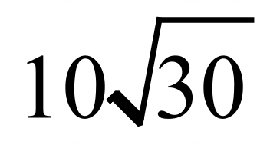 C. 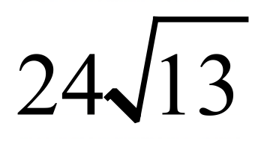 D. 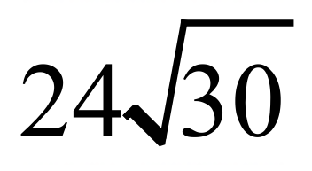
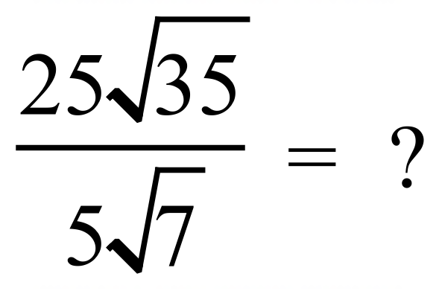

A. 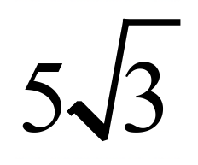 B. 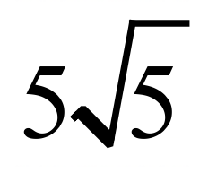 C. 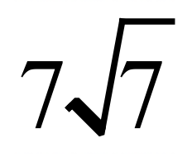 D. 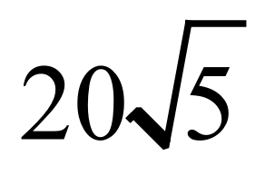
Completely simplify 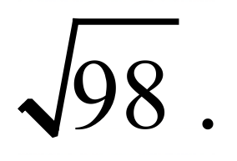

A. 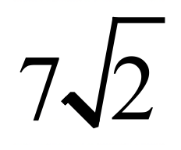 B. 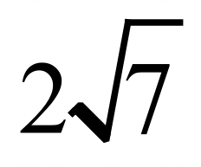 C. 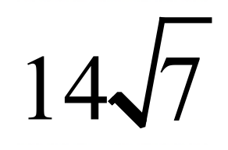 D. 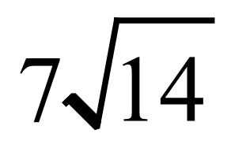
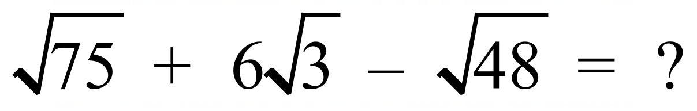

A. 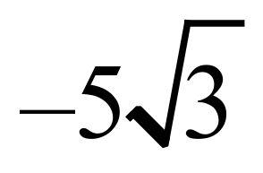 B. 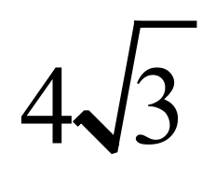 C. 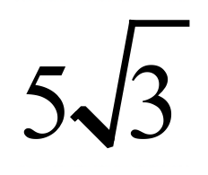 D. 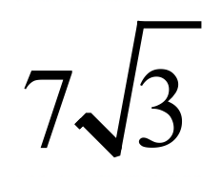
 | A. 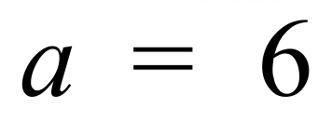 B. 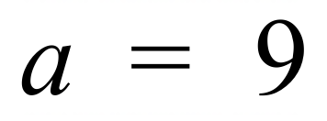 C. 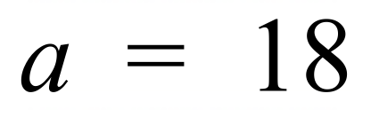 D. 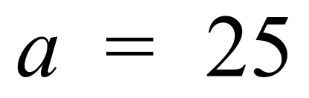
Which of the following is the largest?

A. 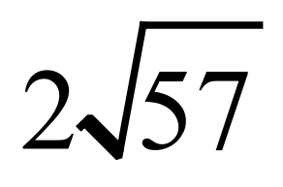 B. 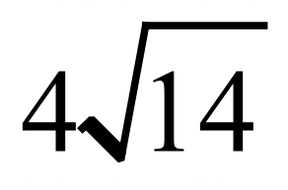 C. 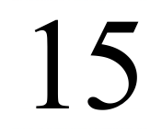 D. 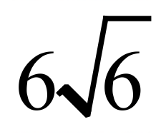


A. 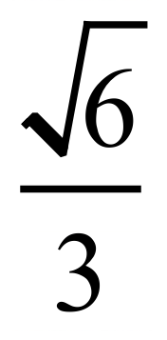 B. 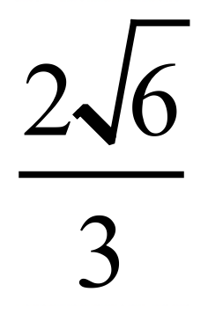 C. 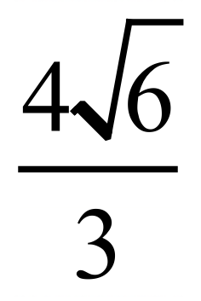 D. 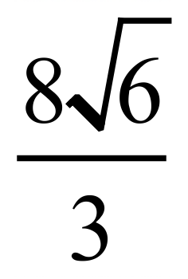
Expand and simplify 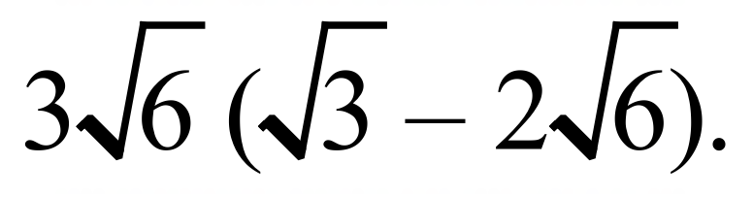

A. 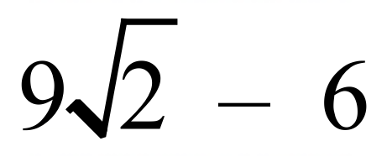 B. 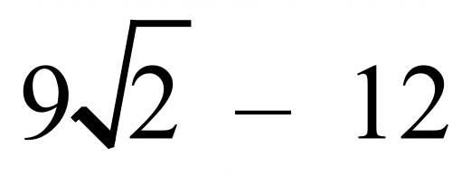

C. 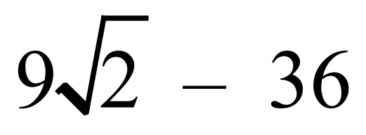 D. 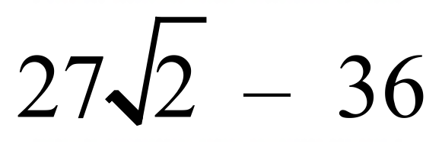
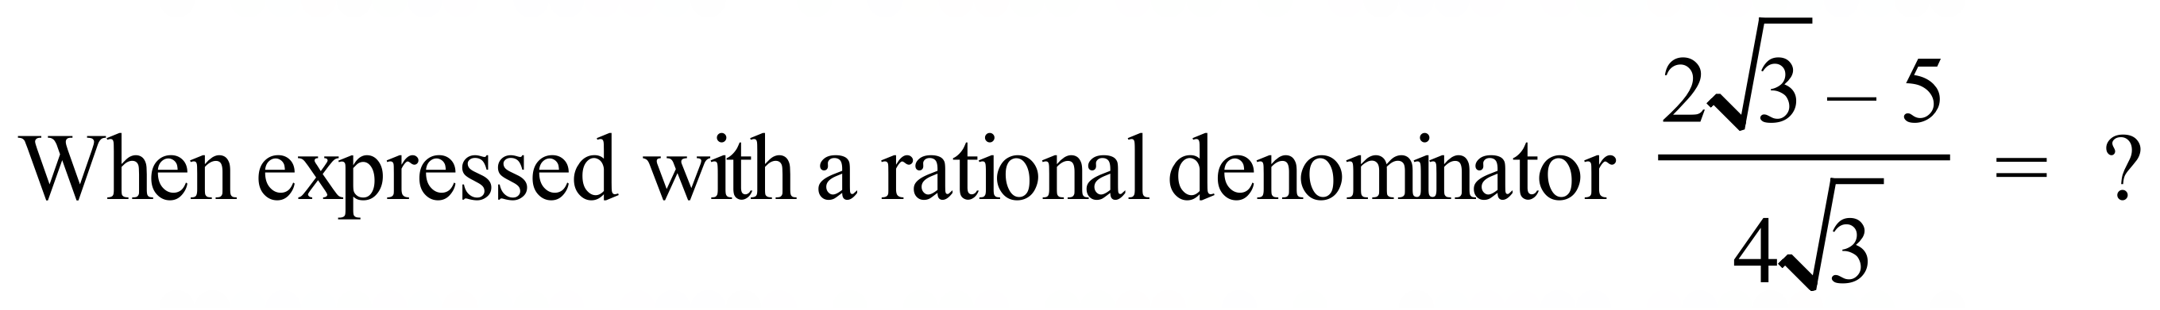

A. 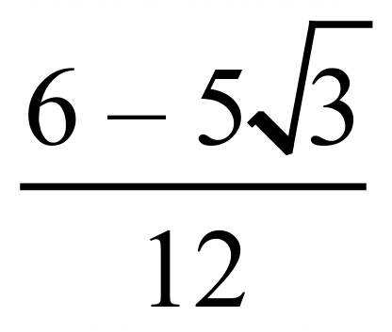 B. 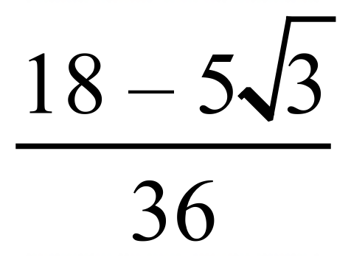
C. 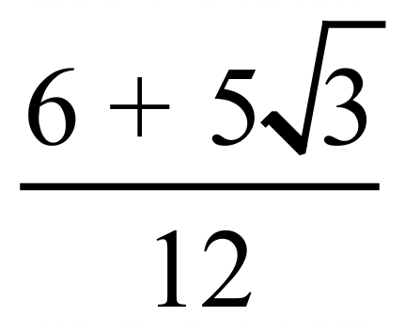 D. 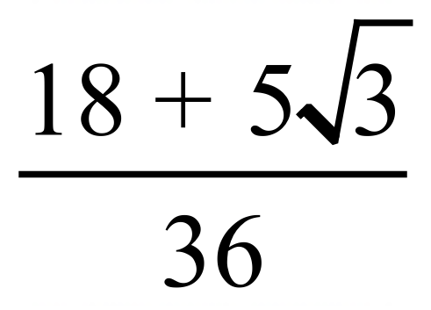
Expand and simplify 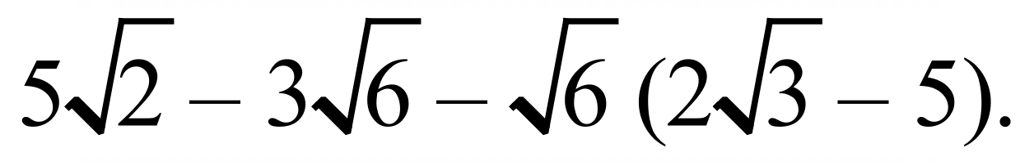

A. 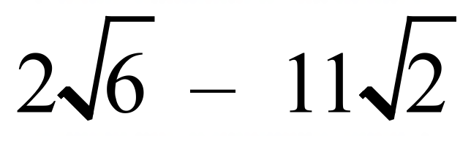 B. 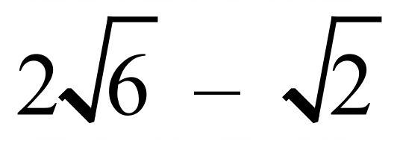

C. 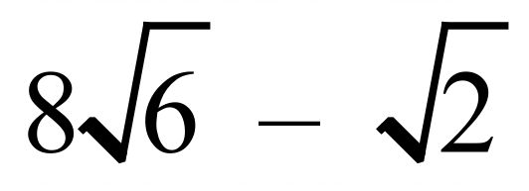 D. 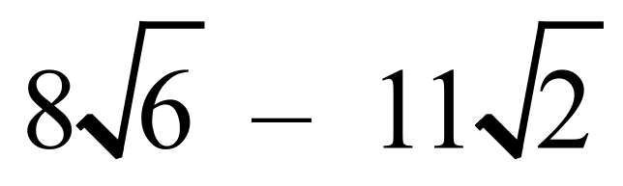
Expand and simplify 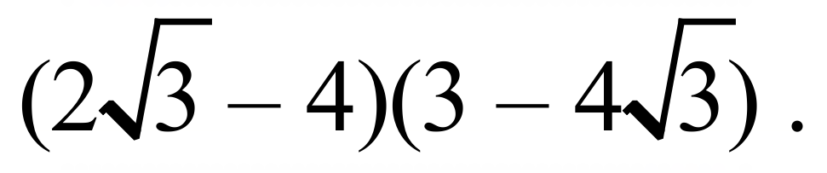
A. 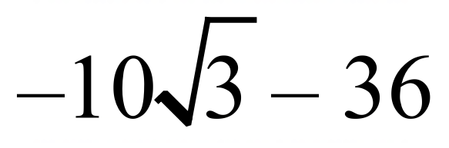 B. 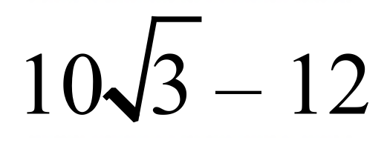

C. 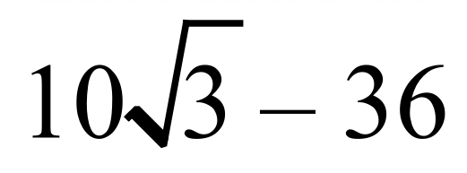 D. 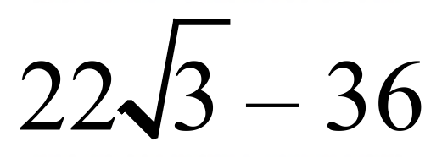
Given that the centre for the arc drawn below is the point O on the number line, and AB is perpendicular to OP, what number is represented by the point P?
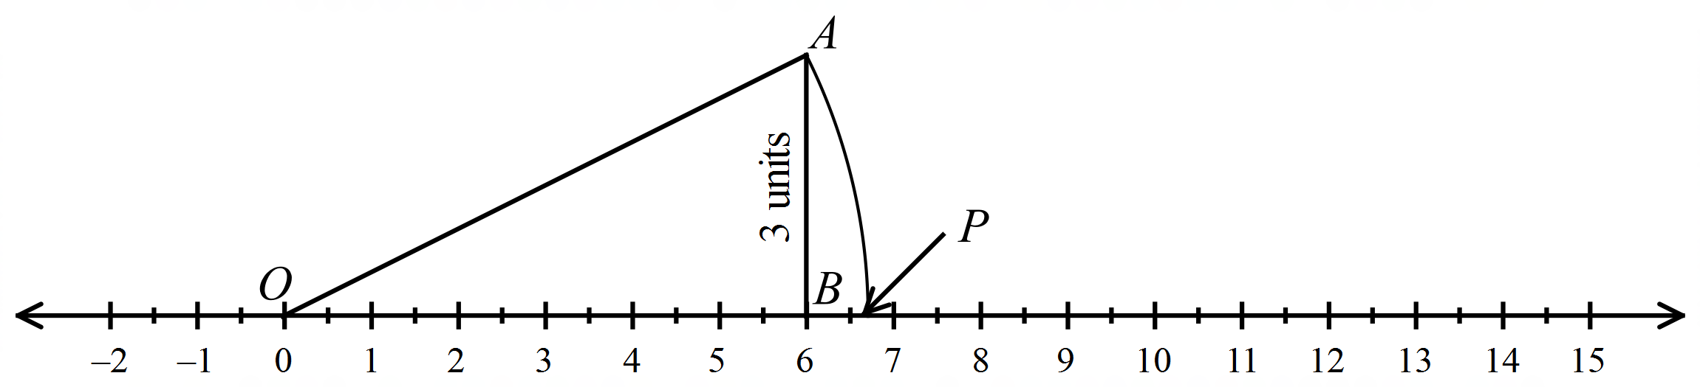

A. 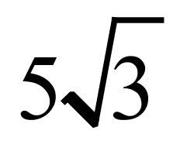 B. 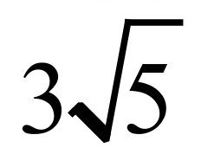 C. 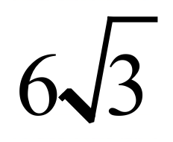 D. 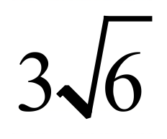

School Name
Mathematics Test 2017
Year 9 | Surds | Calculator Allowed
Year 9 | Surds | Name___________________
Section 3 Longer Answer Section
Write all working and answers in the spaces provided on this test paper.

 |  | Marks
1. | - Express 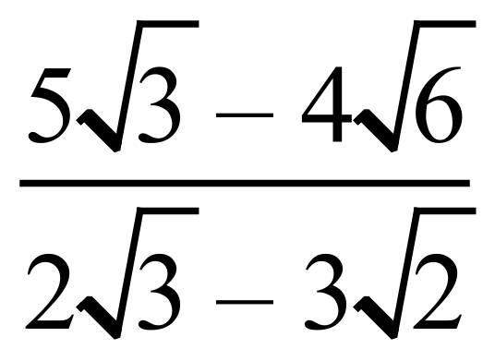 with a rational denominator.  ……………………………………………………………………………………………….  ……………………………………………………………………………………………….  ……………………………………………………………………………………………….  ………………………………………………………………………………………………. | 2
 | - Simplify the following, giving your answer as a single fraction in simplest form.  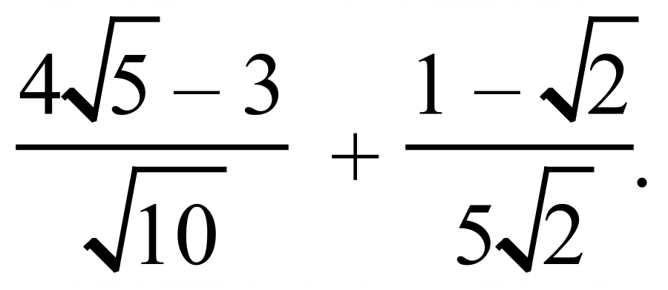  ……………………………………………………………………………………………….  ……………………………………………………………………………………………….  ……………………………………………………………………………………………….  ……………………………………………………………………………………………….  ……………………………………………………………………………………………….  ………………………………………………………………………………………………. | 3
 | - Express 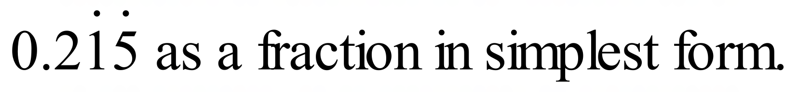  ……………………………………………………………………………………………….  ……………………………………………………………………………………………….  ………………………………………………………………………………………………... | 2

School Name
Mathematics 2017
Multiple Choice Answer Sheet
Surds
Name _____________________________________________
Completely fill the response oval representing the most correct answer.
1. A B C D
2. A B C D
3. A B C D
4. A B C D
5. A B C D
6. A B C D
7. A B C D
8. A B C D
9. A B C D
10. A B C D
11. A B C D
12. A B C D
13. A B C D
14. A B C D
15. A B C D

School Name
Mathematics Test 2017
Year 9 | Surds | Non Calculator Section
ANSWERS

Question | Working and Answer
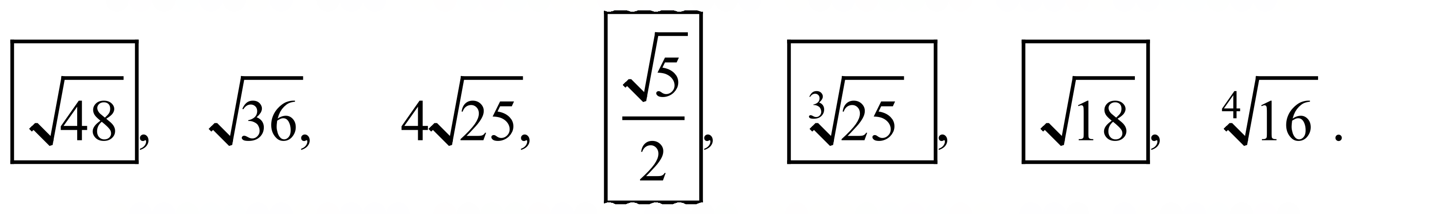
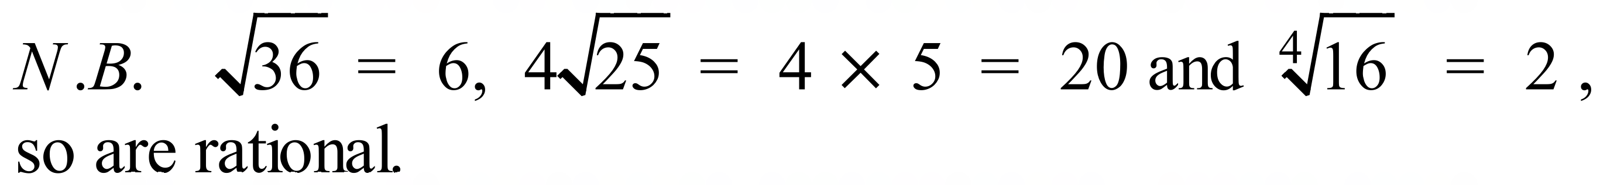
 | 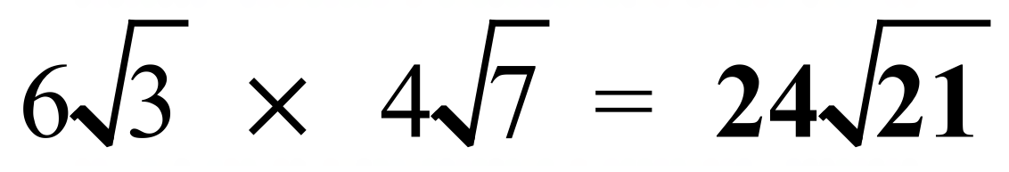
 | 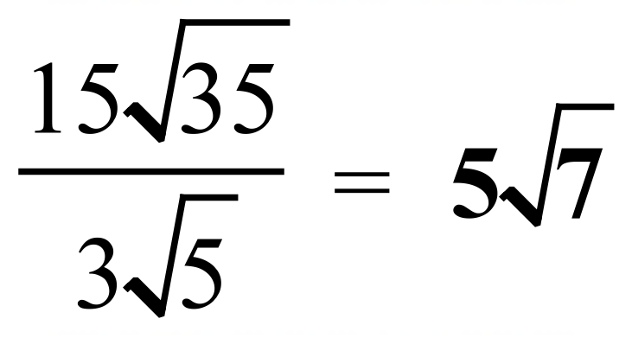
 | 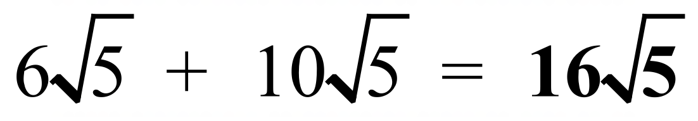
 | 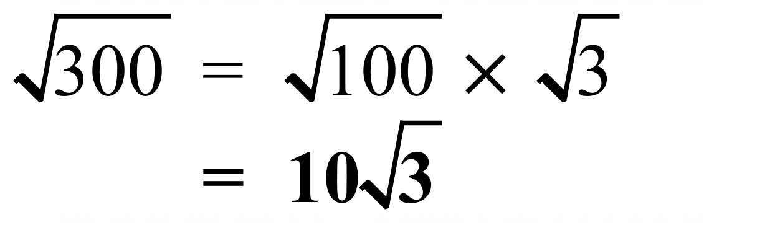
 | 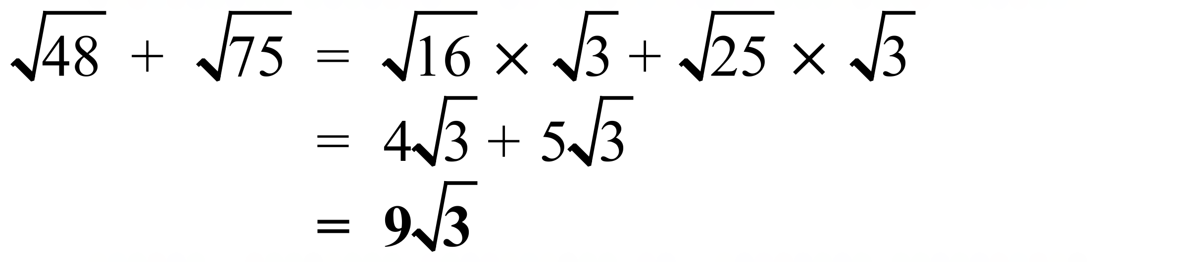
 | 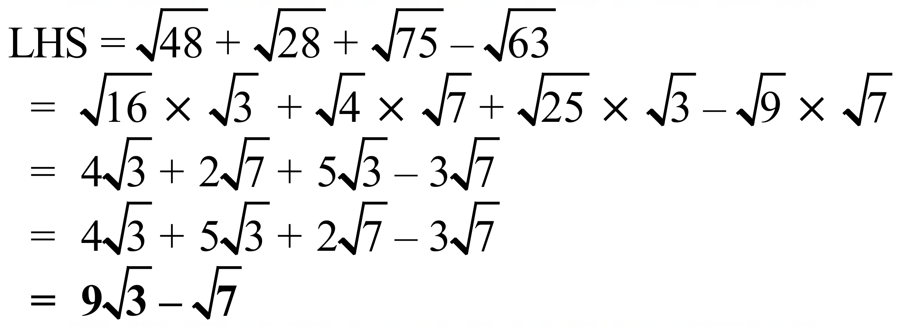
 | 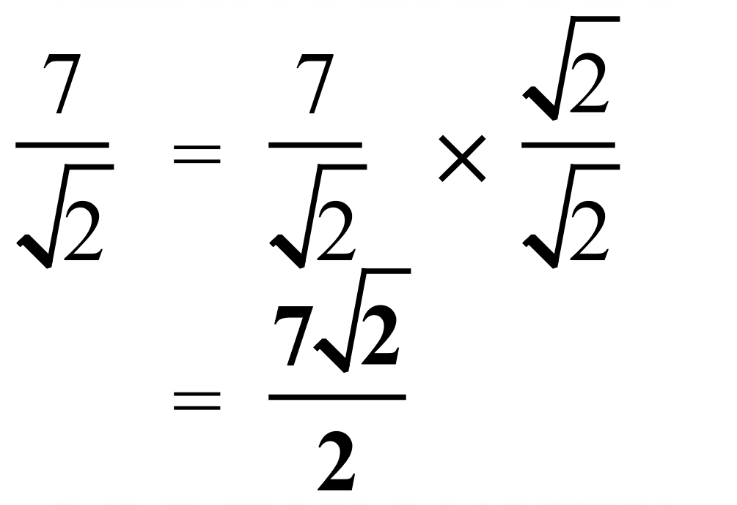
 | 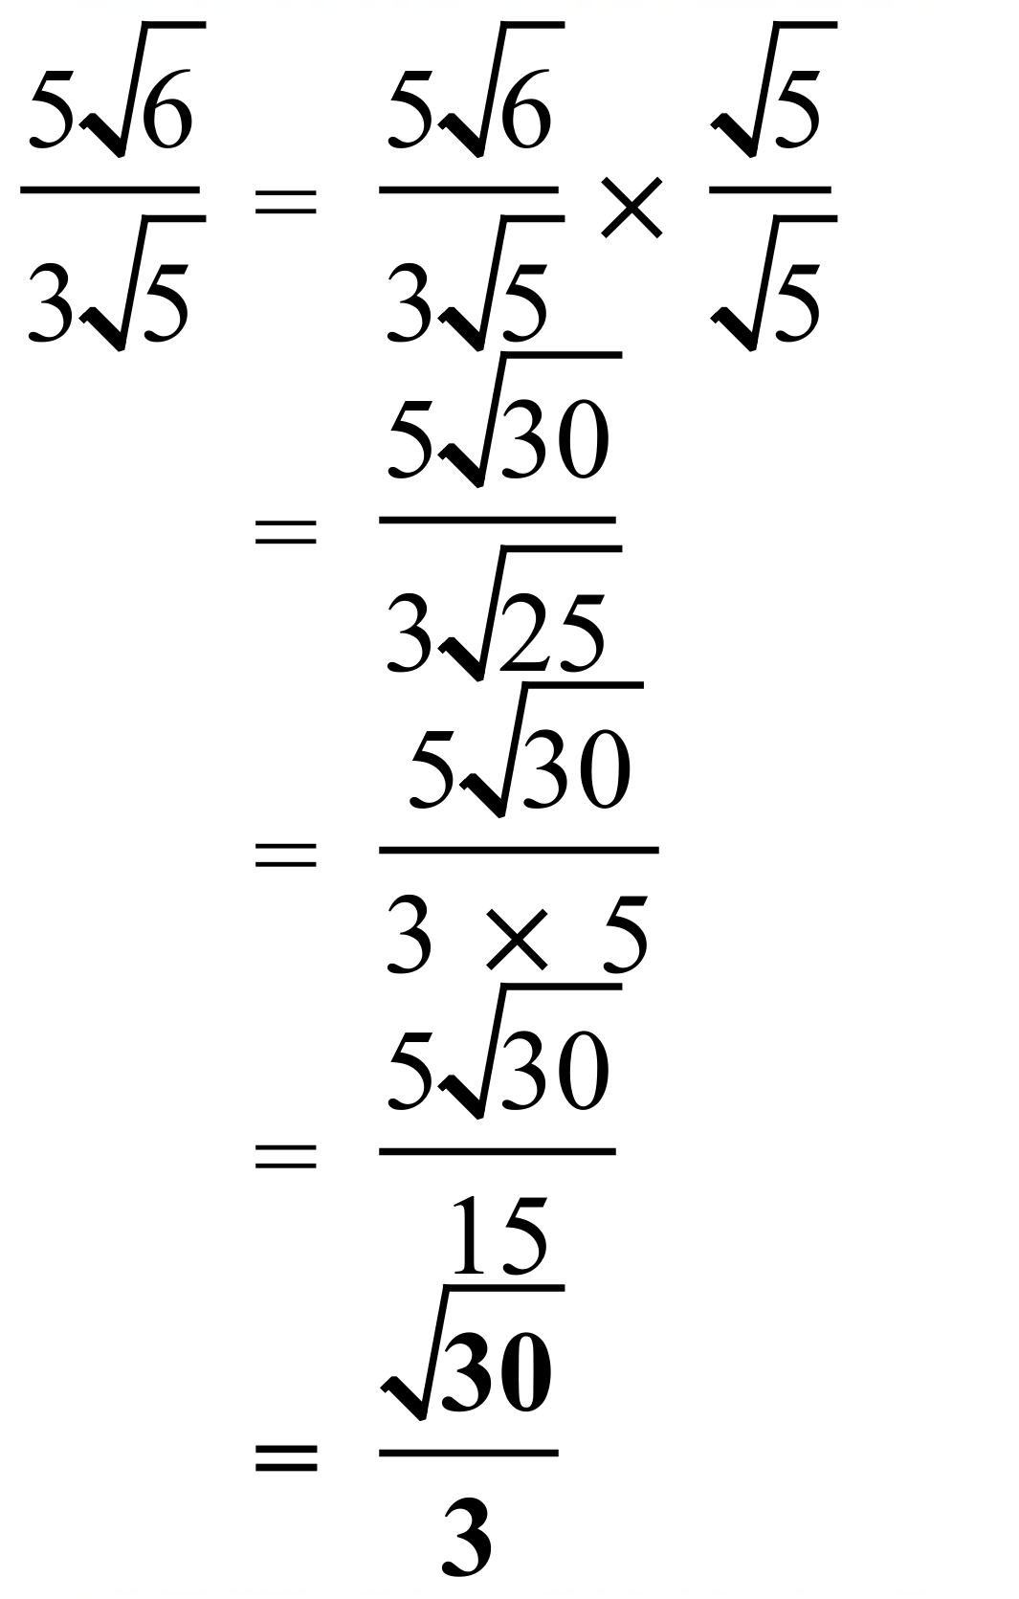
 | 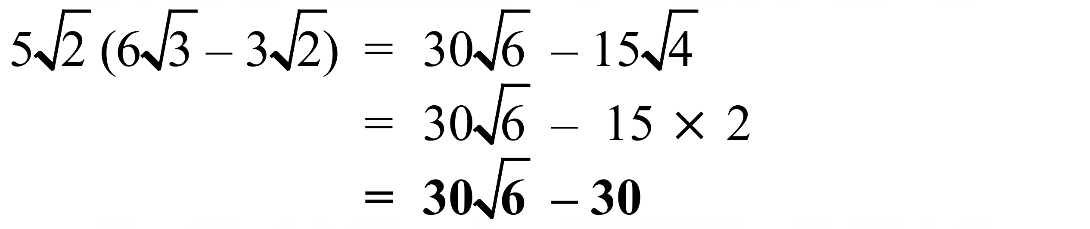
 | 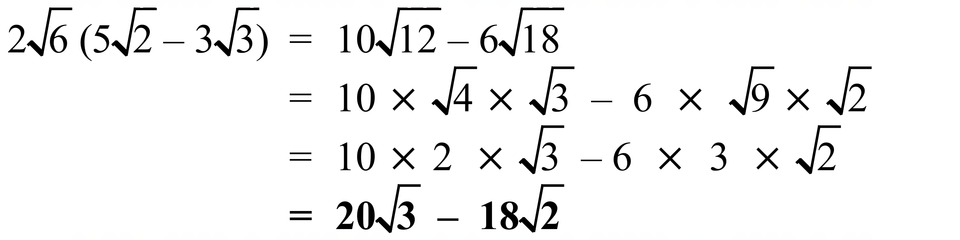
 | 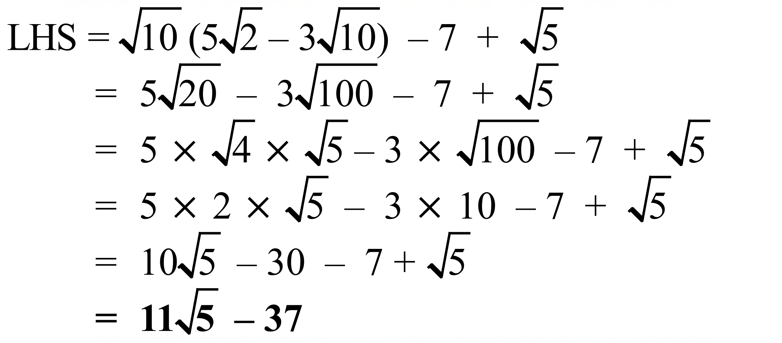
 | 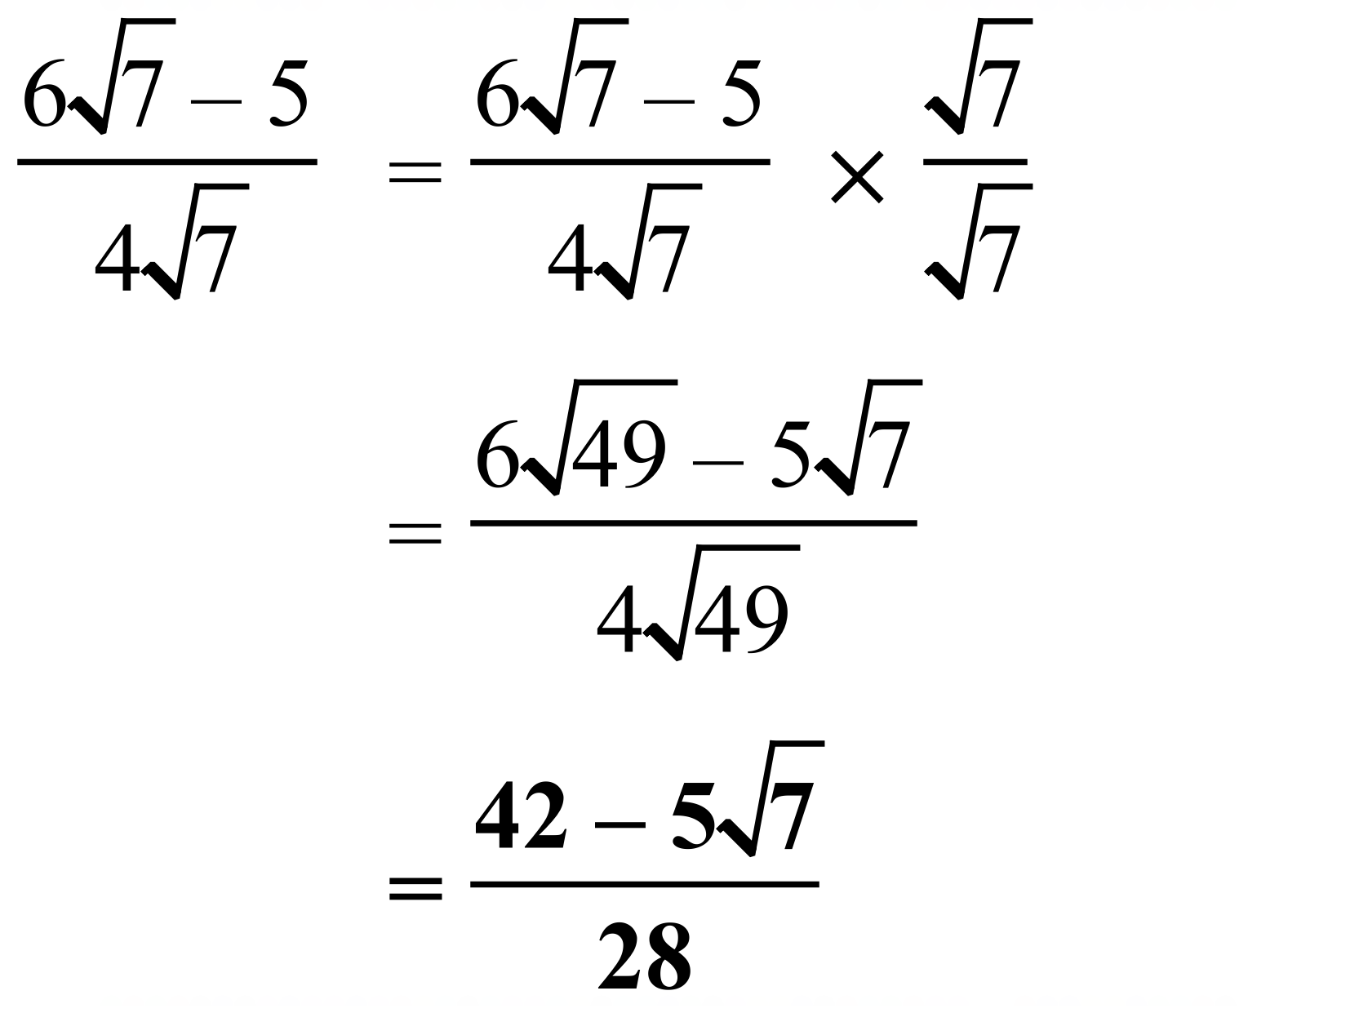
 | 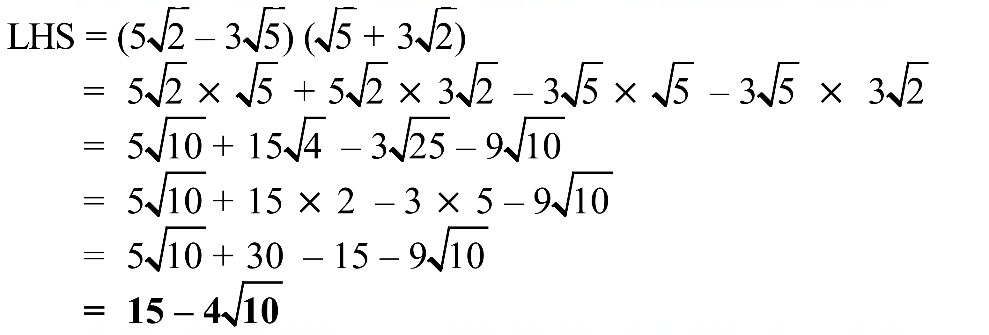
 | 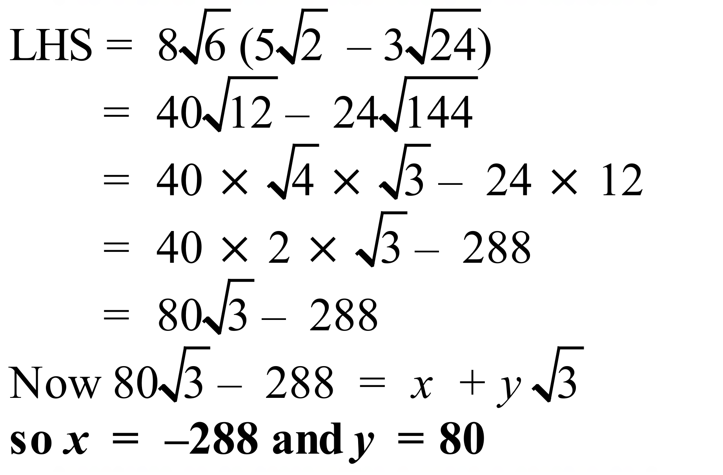
 | 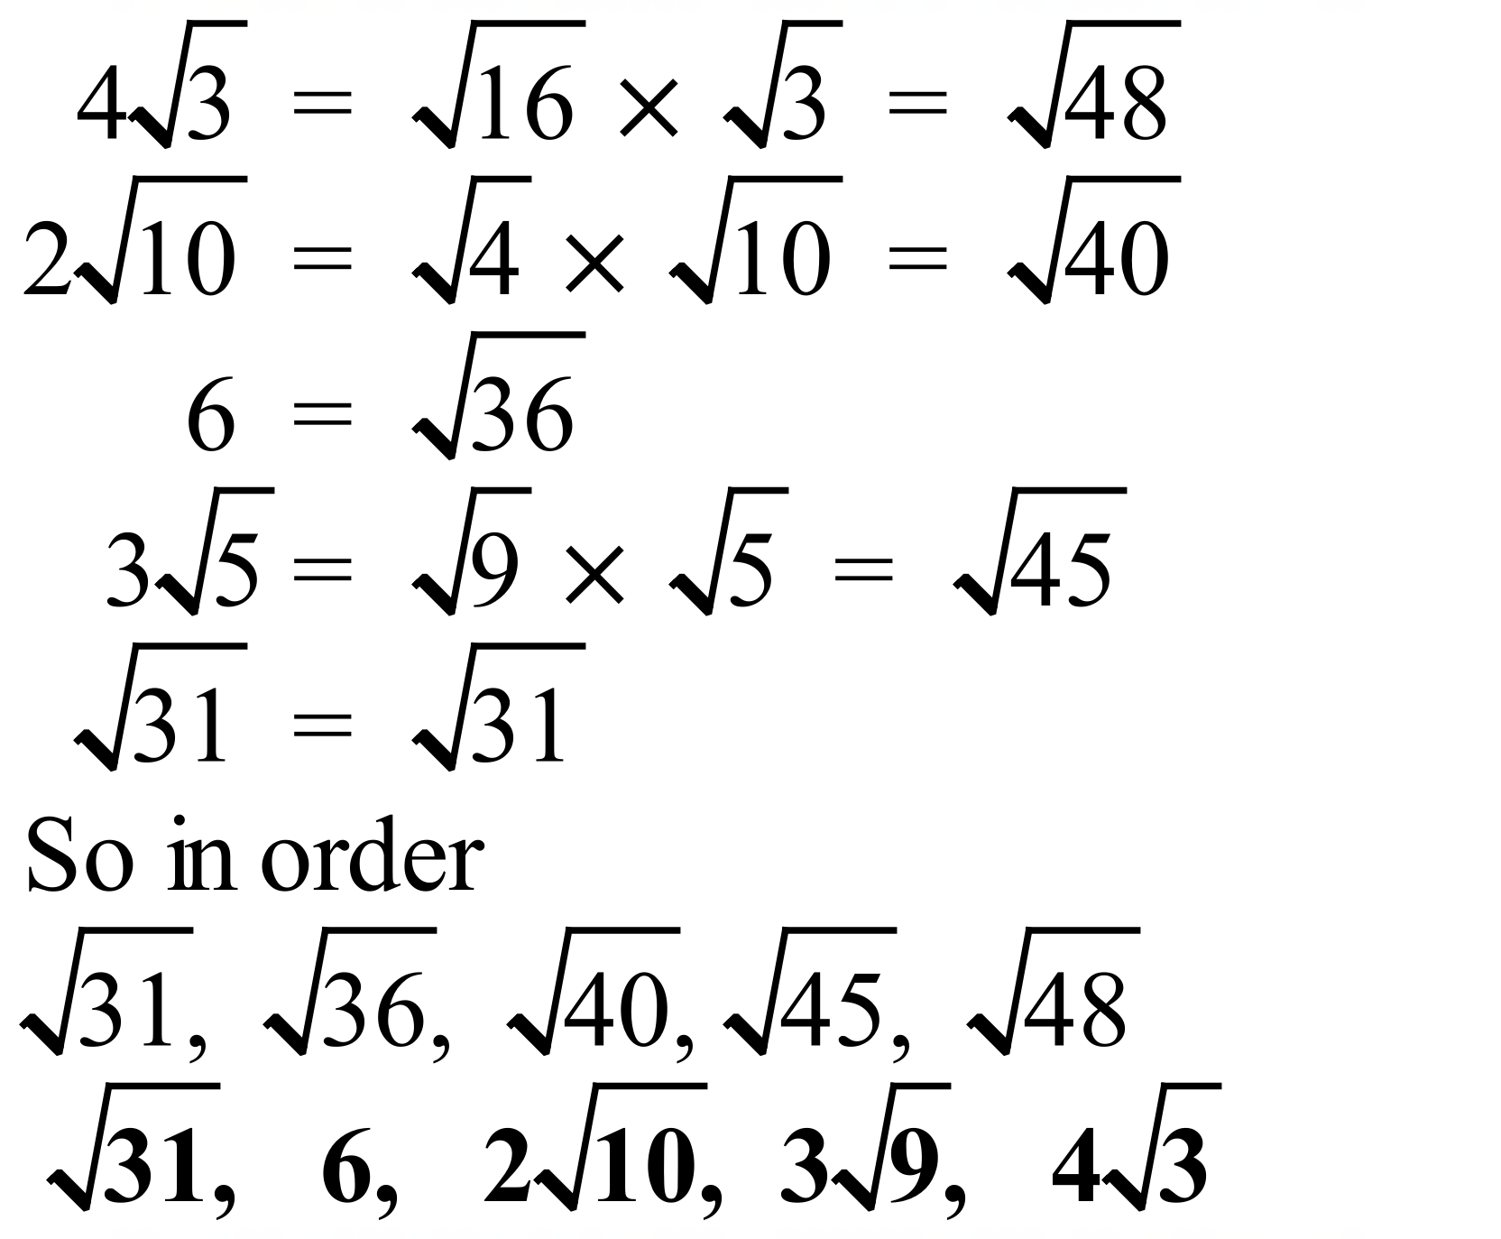

School Name
Mathematics Test 2017
Year 9 | Surds | Calculator Allowed  Multiple Choice  Section

ANSWERS

Question | Working | M C Answer
 | 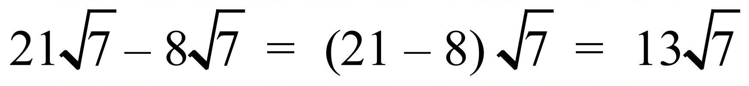 | C
 | 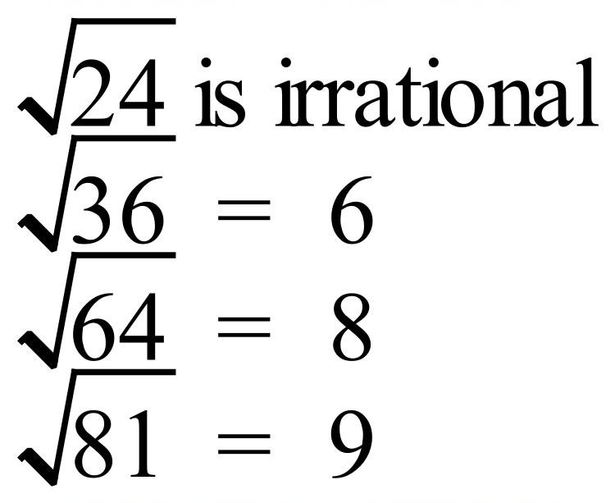 | A
 | 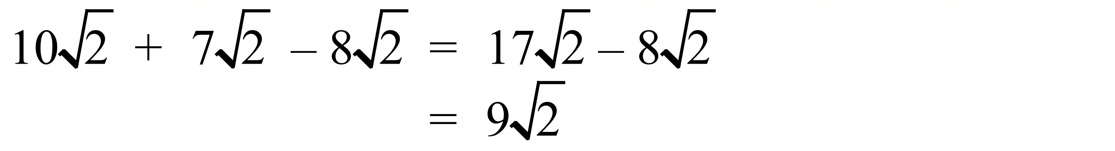 | D
 | 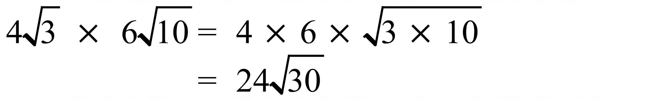 | D
 | 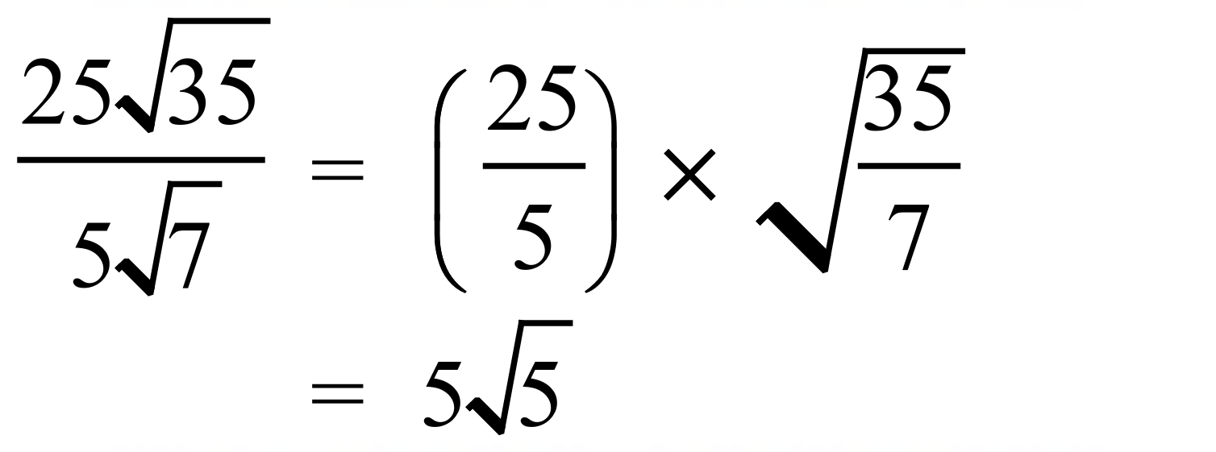 | B
 | 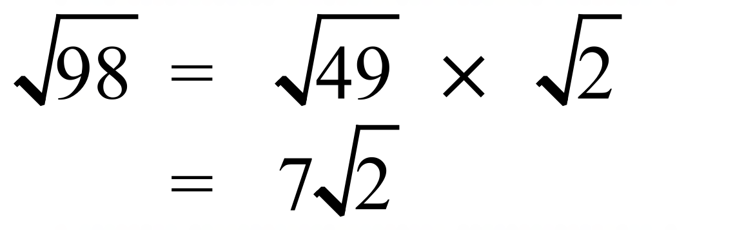 | A
 | 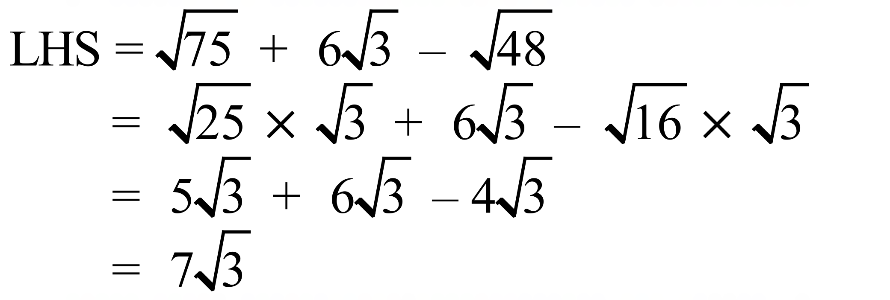 | D
 | 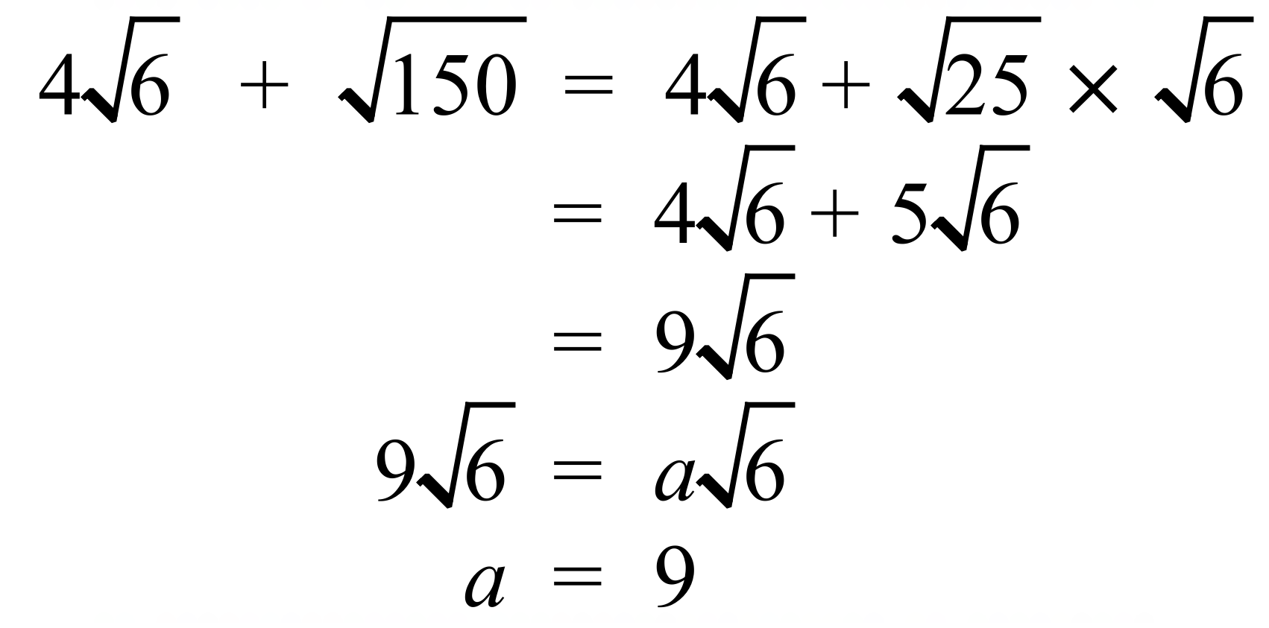 | B
 | 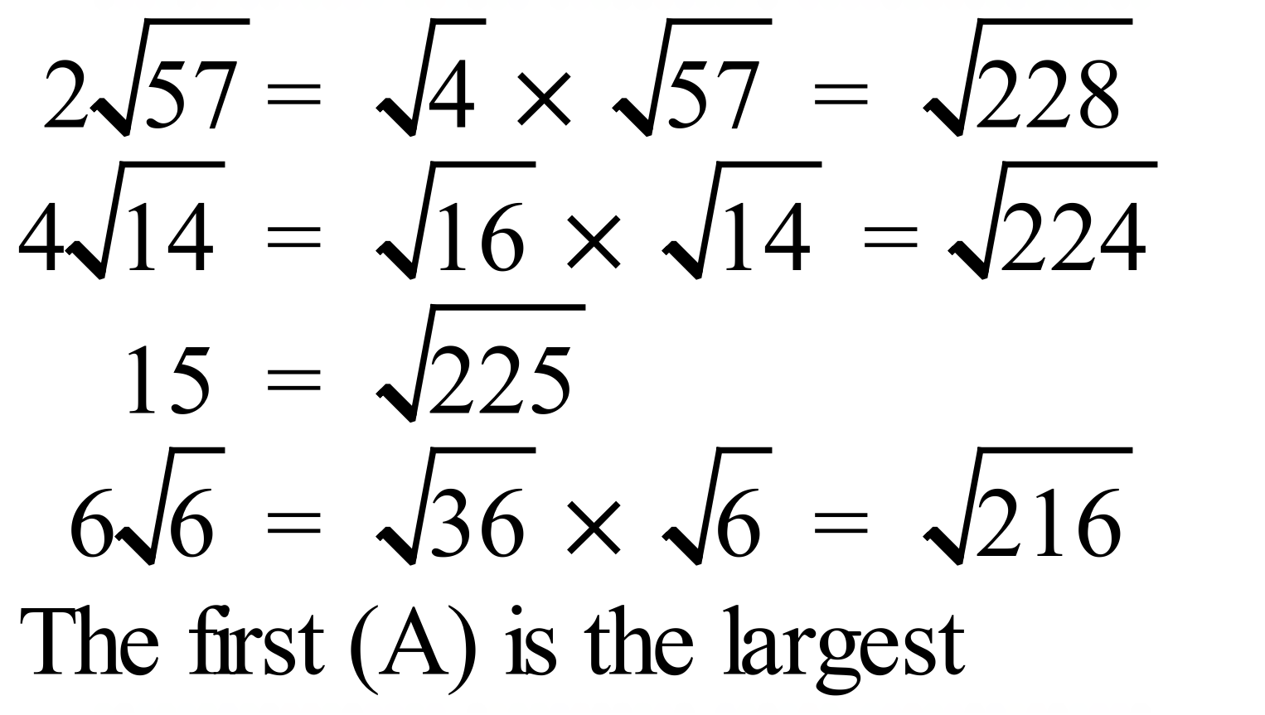 | A
 | 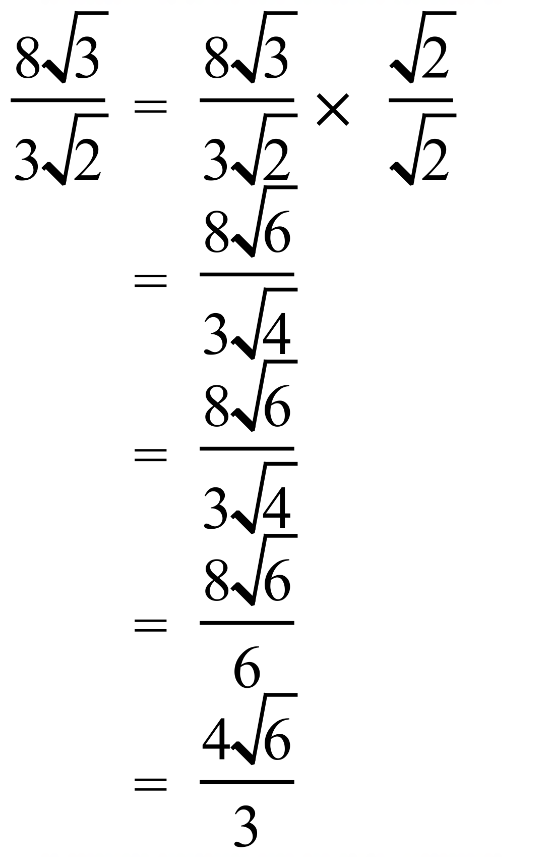 | C
 | 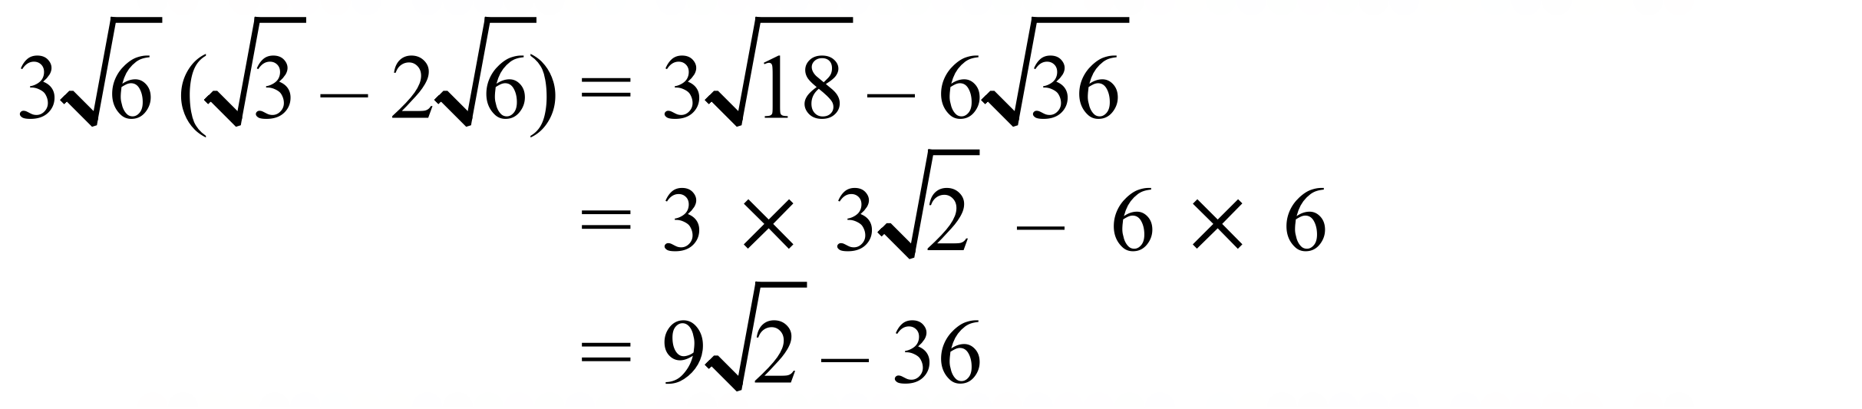 | C
 | 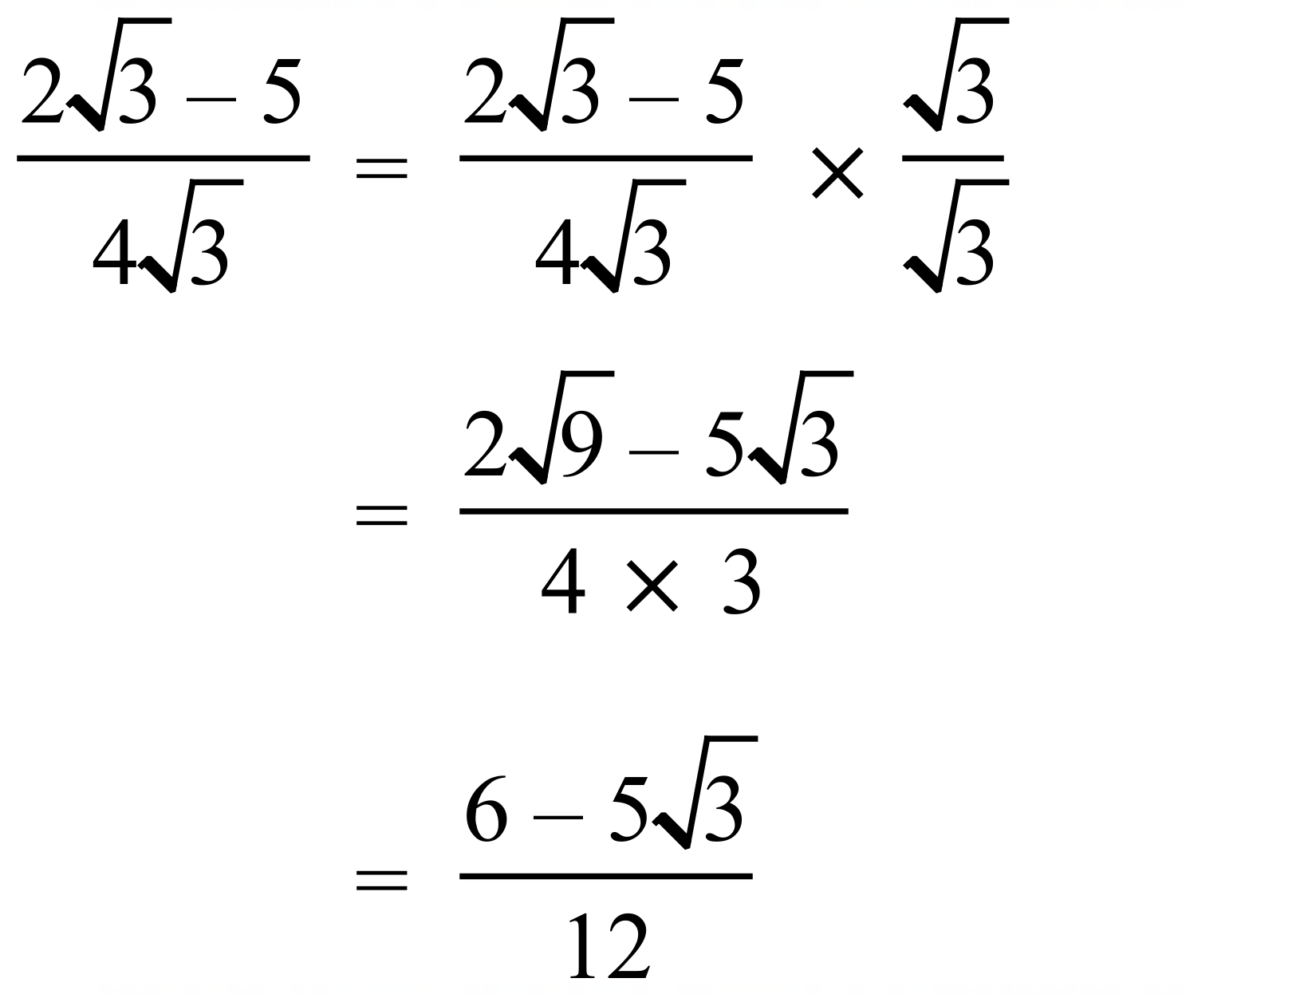 | A
 | 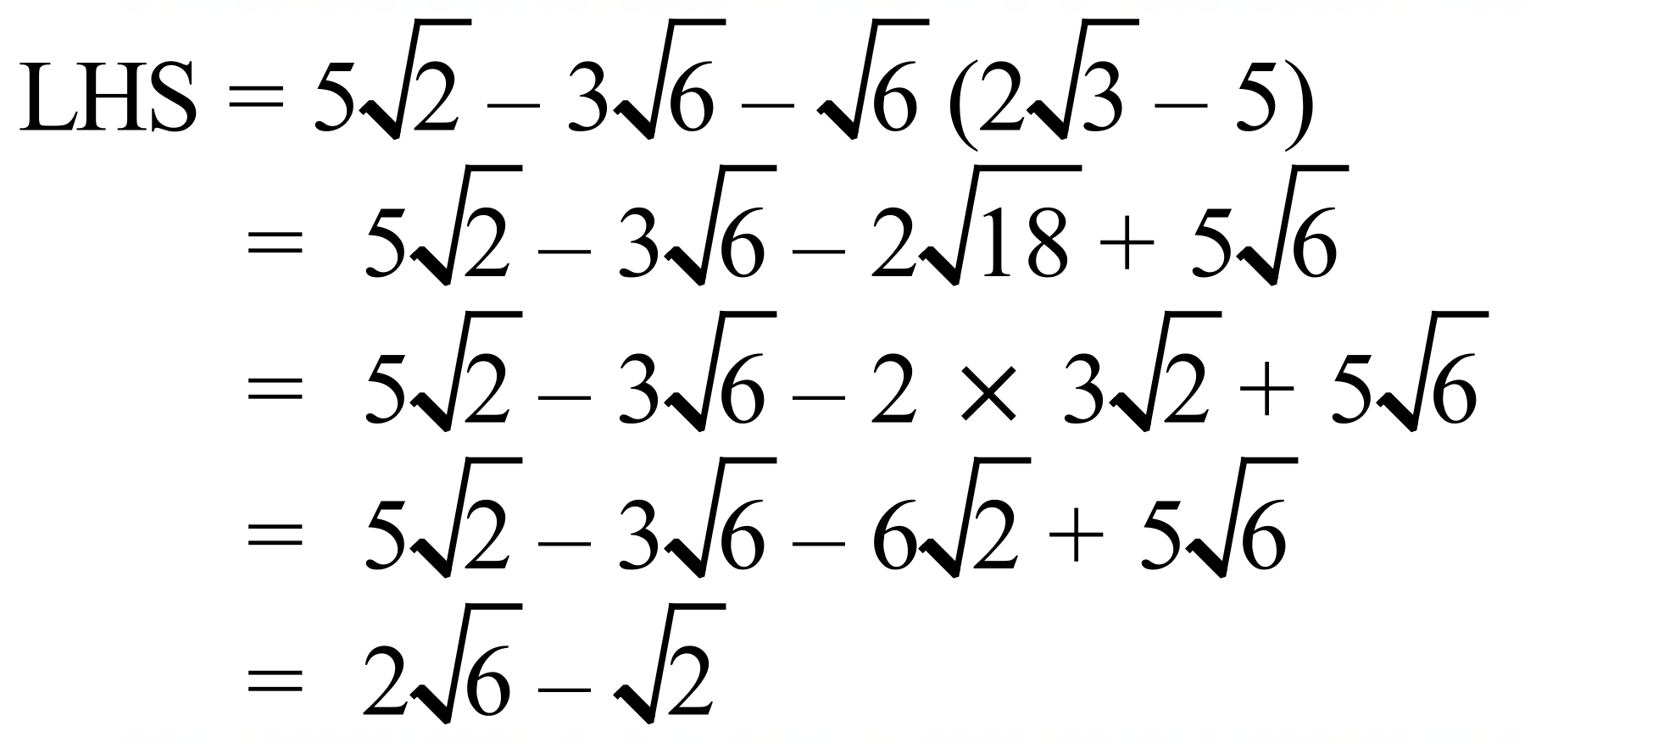 | B
 | 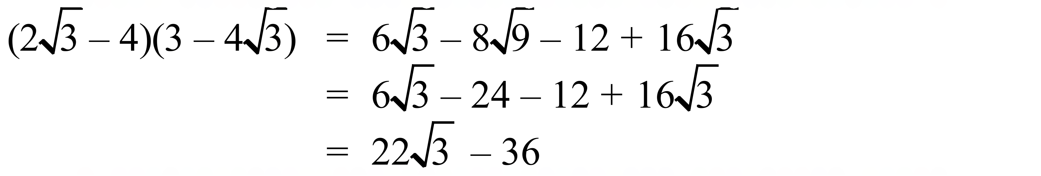 | D
 | 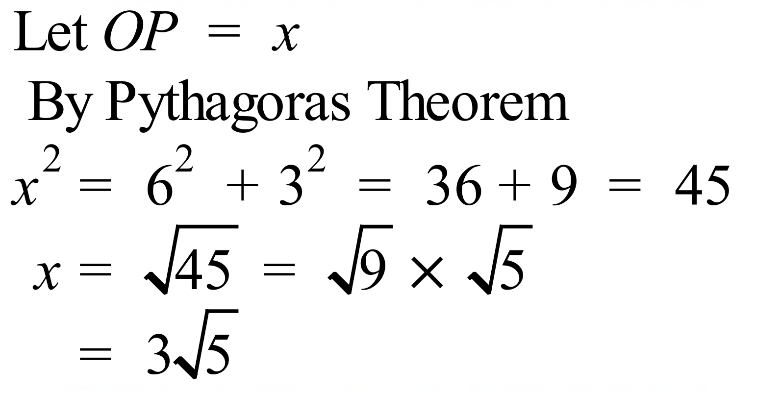 | B

School Name
Mathematics 2017
Multiple Choice Answer Sheet
Surds
Name _____________________________________________
Completely fill the response oval representing the most correct answer.
1. A B C D
2. A B C D
3. A B C D
4. A B C D
5. A B C D
6. A B C D
7. A B C D
8. A B C D
9. A B C D
10. A B C D
11. A B C D
12. A B C D
13. A B C D
14. A B C D
15. A B C D

School Name
Mathematics Test 2017
Year 9 | Surds | Calculator Allowed  Longer Answer  Section
ANSWERS
Question | Working and Answer | Marks
1. | (a) 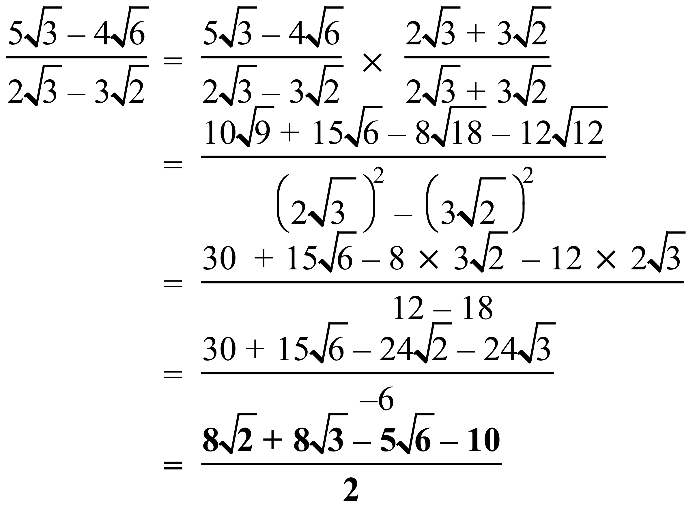 | 2 marks for either of the last two lines of the solution shown.  1 mark for a basically correct attempt which has only a minor error or two in algebra or calculation, or is incomplete but has a correct beginning
 | (b) 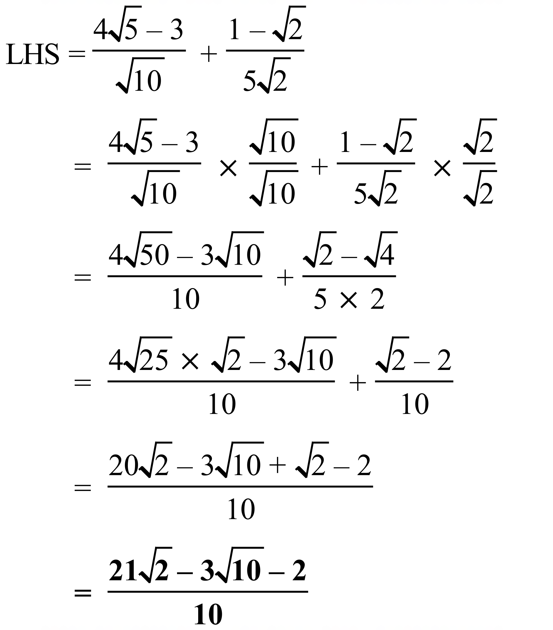 | 3 marks for correct simplified answer.  2 marks for a basically correct attempt which has only a minor error or two in algebra or calculation, or is incomplete but has a correct beginning  1 mark for an attempt with some correct working.
 | (c) 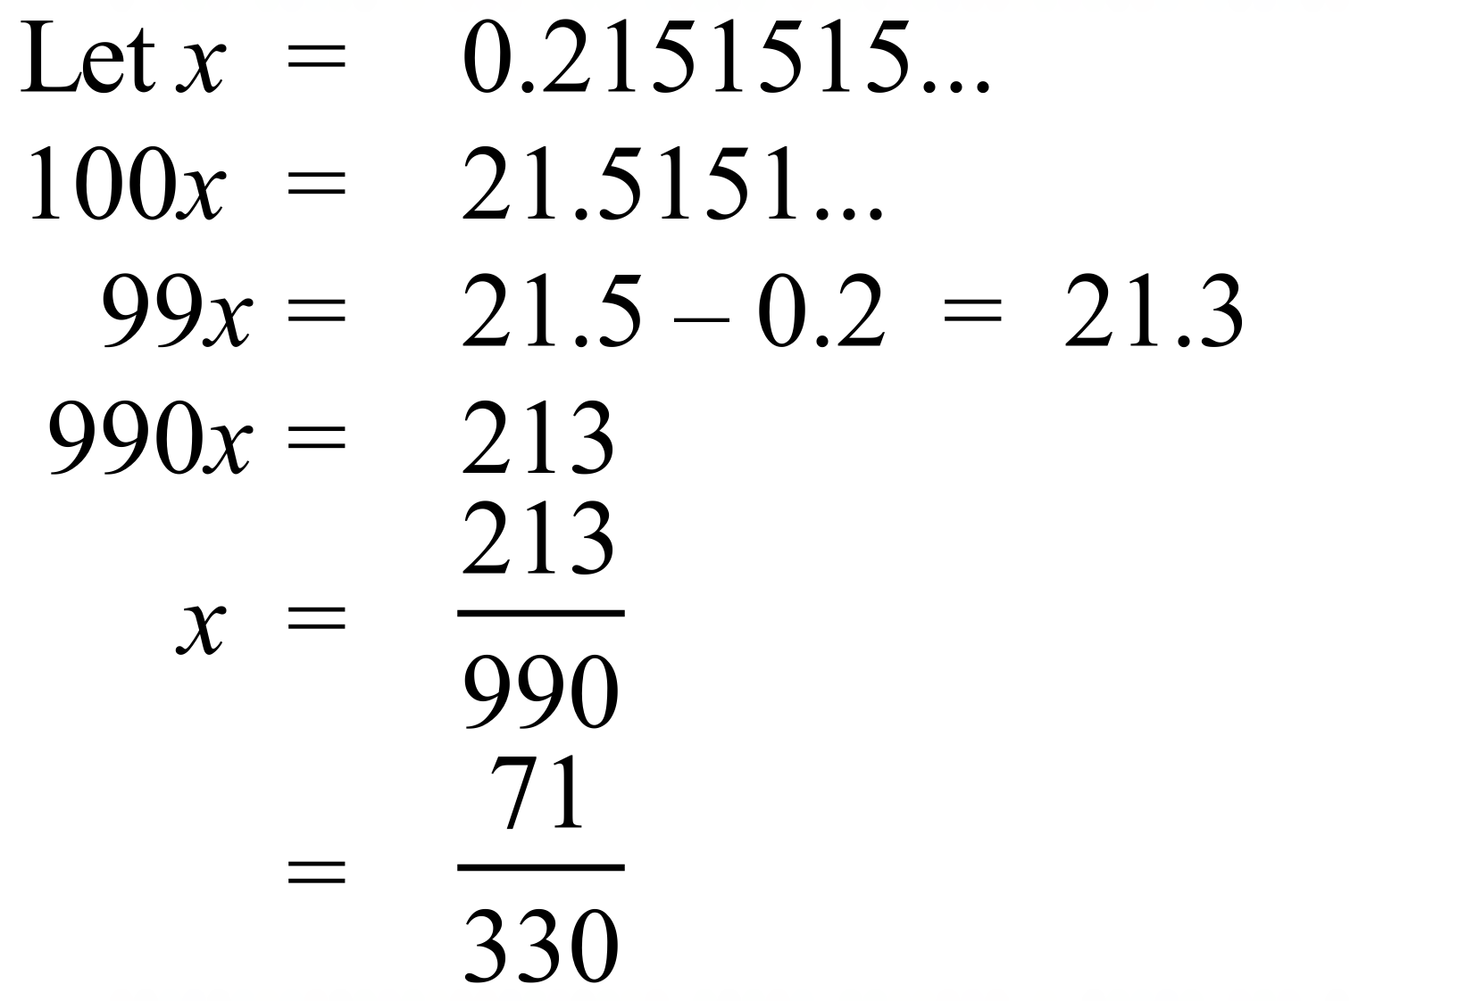 | 2 marks for correct simplified answer.  1 mark for a basically correct attempt which has only a minor error or two in algebra or calculation, or is incomplete but has a correct beginning

